The Kobiona Monitor
Volume 1 / Number 2
January 4, 2019
Kobiona’s leadership has enlisted the help of our Market Intelligence Desk to craft this monthly publication to share major market dynamics impacting future power and gas prices. As every client’s situation is unique, we encourage you to review market movements with us to decide whether any action on your part could serve to lower your future costs or avoid known,
coming increases.
Weather
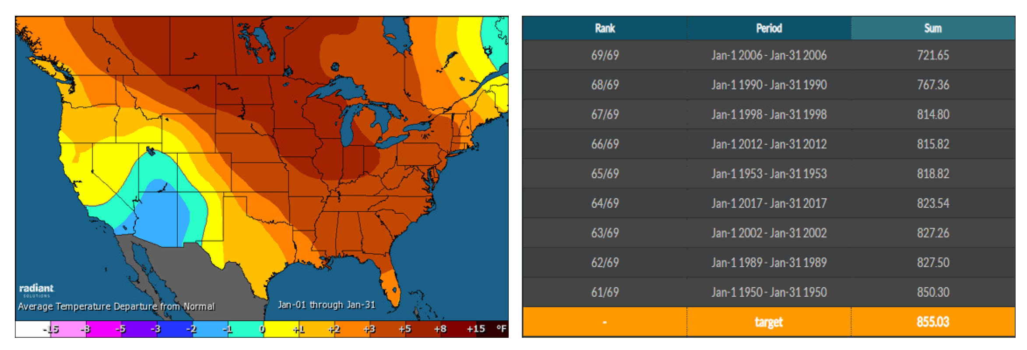
After an historically cold November (9th coldest since 1950), forecasted December cold never materialized and the month ended up the 14th warmest December since 1950.
Arctic air predicted to move into the U.S. still has not done so into early January. The map below shows forecasted temperatures through the 22nd. Based on Heating Degree Days (HDDs) the month is currently trending to be the 10th warmest January on record since 1950, at a target of about 855 HDDs (table on the right, below).

Natural Gas
Natural gas is now the primary fuel source for power plants across the country and throughout New England. As gas prices often closely correlate to power futures, we monitor natural gas supply and demand fundamentals closely.
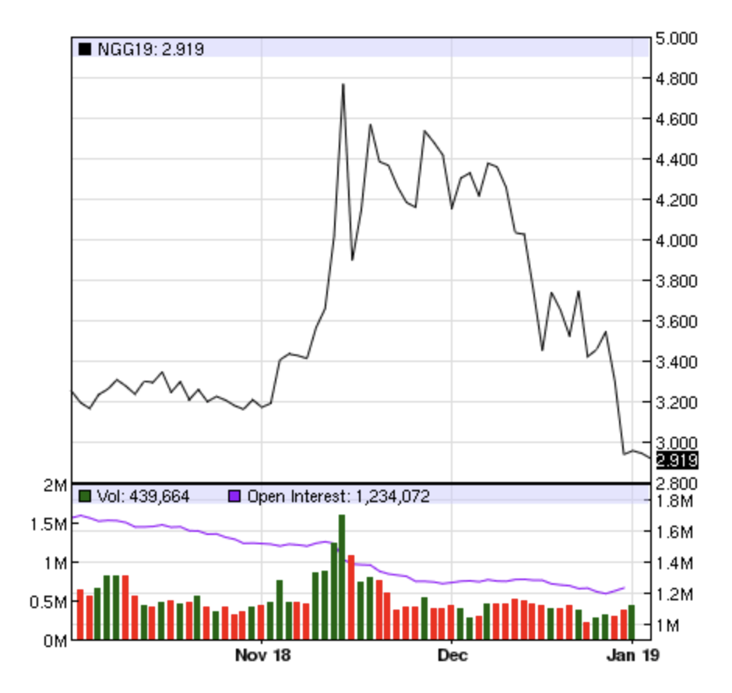
Prompt Month Prices
As of market close on Thursday, January 3rd, the NYMEX prompt month (February) fell to $2.92/MMBTU off a high of nearly $4.80 in late November (for December). The last time the prompt month hit $2.92 was in mid-September.
NYMEX Prompt Month Three Month Lookback

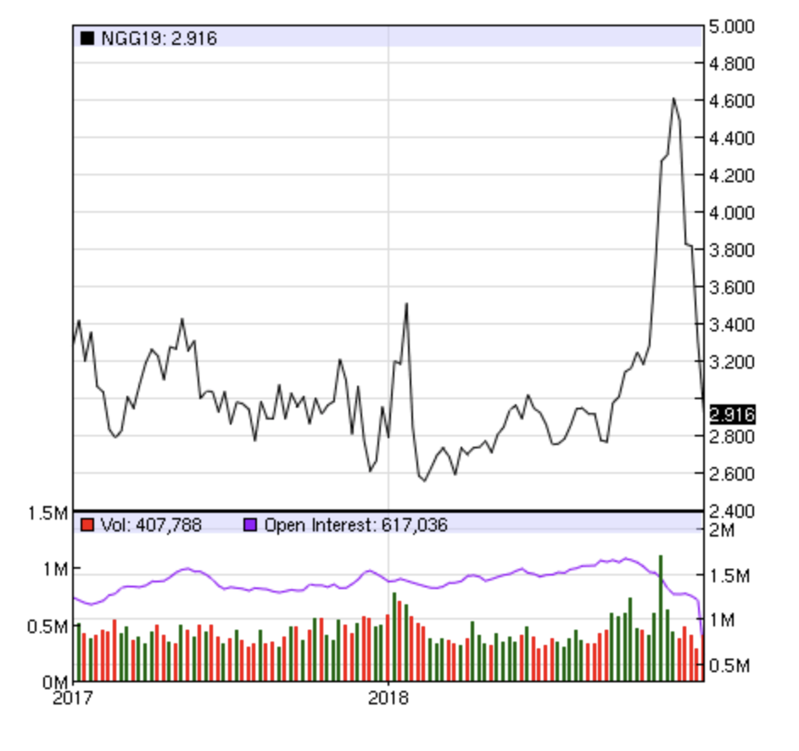
NYMEX Prompt Month Two Year Lookback

Dry Natural Gas Production
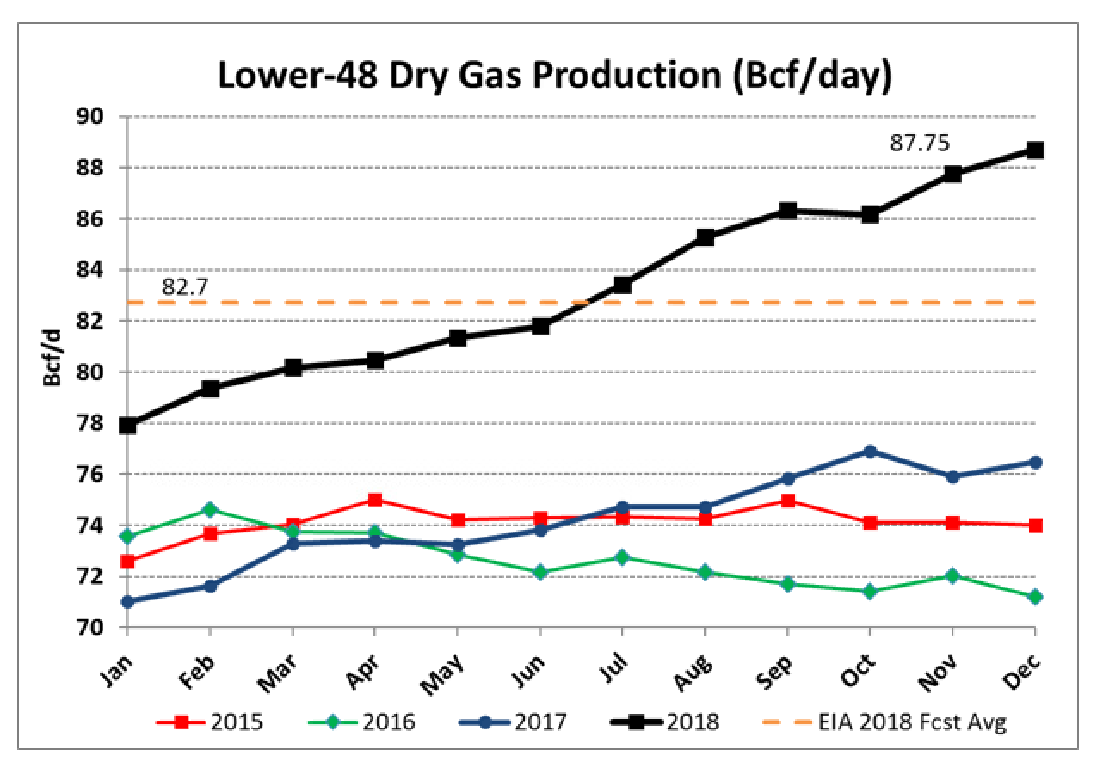
Dry natural gas production broke all previous records in 2018 with November averaging 87.5 Bcf/day and December even higher through mid-month. EIA’s final December numbers will be released on January 10th, and featured in our next issue.

Source: EIA

Dry Natural Gas Storage
The biggest threat to both power and gas future prices throughout 2018 was the seemingly impenetrable deficit of natural gas in storage relative to the five-year average.
The EIA’s January 4th Weekly Storage Report (released this morning for the week ending December 28th) reported inventories of 2,705 Bcf, 450 Bcf less than this week last year, and 560 Bcf below the five-year average of 3,265 Bcf.
While there is a lot of winter left to go, warmer-than-expected temperatures and slowed heating demand have served to narrow the storage deficit to the 5-year average by 2% — from 19% to 17%. This is bearish news for buyers right now, but cold in late January through March could quickly reverse this trajectory.

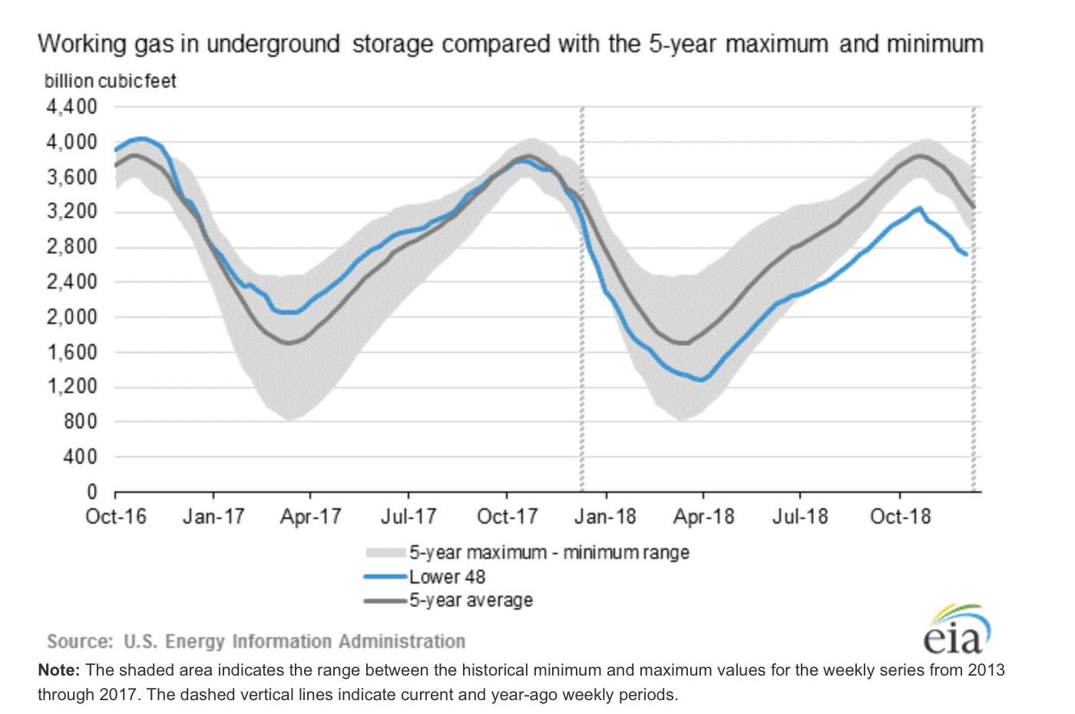

New England Regional News
ISO-NE, the independent system operator responsible for the management of the New England power grid, announced the preliminary Peak Hour for summer 2018, impacting prices for Capacity Year 19/20 (starting June 1, 2019) is Wednesday, August 29th at HE (Hour Ending) 17 (from 4-5 pm).
Source: ISO-NE
Contracting Tip of the Month: Negotiating Onsite Generation
Many energy buyers are unaware of the consequences of integrating solar or other onsite generation into their facility. Power suppliers can levy penalties for reduced usage during current agreements and/or limit future product options (as in not offering fully fixed prices) if onsite generation is installed. If you are considering installing solar or other co-gen, Kobiona can help you negotiate special provisions to prevent penalties and undesirable product restrictions.

Questions?
For those tasked with procuring power and gas for the first time — or the tenth time — the industry can seem overwhelming with densely-technical and sometimes conflicting information.
We welcome your questions on how to apply our observations, as well as your feedback on The Kobiona Monitor. Please share how we can make this publication more useful by calling us on 844-209-7972, or contacting us via email, info@kobiona.com.

